Cognos Framework Manager

Lab Guide

Table of Contents

Lab 01 – Create the Project 3
Lab 02 – Create the New data source and Import the Metadata. 14
Lab 03 – Merging the two Query Subjects 17
Lab 04 – Creation of New Query Subjects: 22
Lab 05 – Resolving Ambiguous Relationships. 37
Lab 06 – Multi Database Access 39
Lab 07 – Creation of Parameter Maps: 45
Lab 08 – Create a macro to change the multilingual column names dynamically. 47
Lab 09 – Creation of Query items and Filters and Model Filters and Model Calculations. 51
Lab 10 – Creation of Package and Publish Package. 58
Lab 11 – Update and Synchronize 62

Lab 01 – Create the Project

- Objective :

Create one Project and to create one Business Model by using the Existed data source for Organizing Query Subjects:
- Steps

- Go to the Framework Manager, we have two options like “create a new Project” and “Open a Project”.
- Click on Create a New Project link.
- Enter the Project name in the ‘Project Name’ field. Project Name should be having Naming Conventions and the name should be the same of the Project Name. Ex: “Gosales and Goretailers”
- For project Location, it takes the default path is where we installed the cognos in our machines. But for better practice is create one project folder and give that folder path in this location.
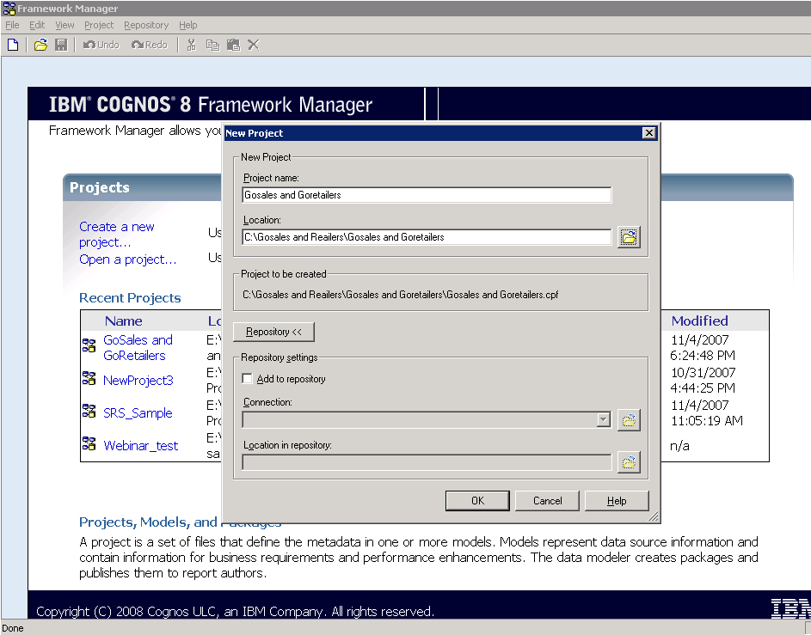

- Click on “OK” button.
- As we know, cognos is a multilingual product and it supports multiple languages. But By default it is in English. Click on OK button.

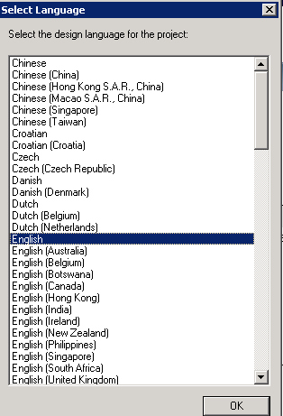

- Now we will get the Metadata Wizard Screen. Here we have so many options to import the metadata. Those are
Data Sources: If we want to import the metadata from the data sources, then we can use this option.
IBM Cognos 8 Model: If we want to reuse the existed cognos8 model, then we can use this option.
IBM Cognos Architect (*.xml): If we want to import the metadata from Cognos Architect (*.xml), then we can use this option.
IBM Cognos Impromptu (*.xml): If we want to import the metadata from Cognos Impromptu (*.xml), then we can use this option. For Migration type of projects we can use this option.
If we want to import the Metadata from ETL Tools of Cognos, then we can go for the options like IBM Cognos 8 Decision Stream (*.xml) and IBM Cognos8 Data Manager.
IBM Metadata Sources: If we want to import the metadata from IBM Metadata Sources, then we can select this one.
Third Party Metadata Sources: If we want to import the metadata from third party sources like SAP, BO then we can use this option.

Depends upon the requirement, we can select any one of the above option. In this Lab book, we can go for “data Sources” option.
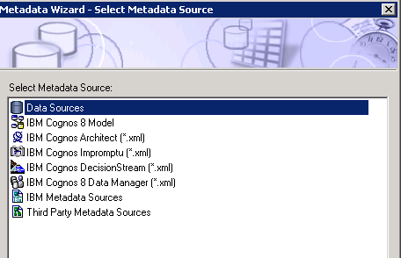
- Select the Data sources and click on “Next” button.
- Select the ‘Go Sales’ database and click on Next button. If ‘Go sale’ is not available then select any one of the Existed database and click on “Next” button.
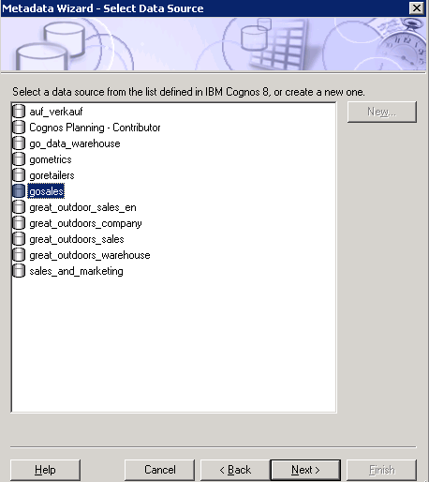

- Select the Required objects in “GOSL” database in the Metadata Wizard – Select Tables window. Expand the “Tables” icon and select the required tables.
- Select the required tables like Country, Order Header, Order Method, Order Details, Product, Product Forecast, Product Line, Product Multilingual and Product type.
- Here, we have two options like while importing these tables, if we detect a duplicate Name first thing is “Import and Create a duplicate Name” and the second thing is “Do not import this object”. By default it is selected for “Do not import this object” option.
- If we want to see “System objects” then check the checkbox for ‘Show System Objects’.
- Click on the Next button.

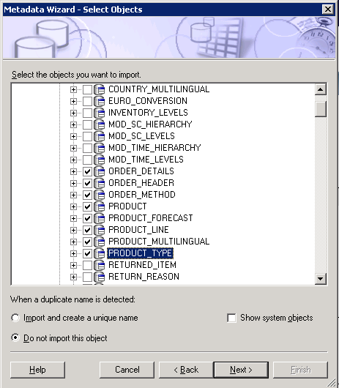

- Uncheck the Check box for “Use Primary and Foreign Keys” check box in the Metadata Wizard – Generate Relationships Wizard.

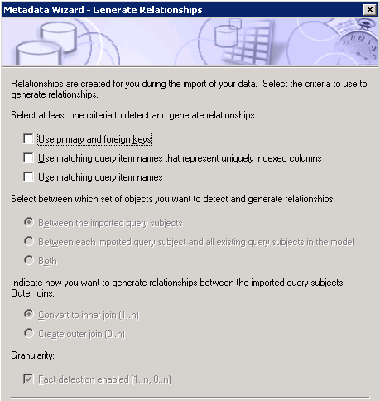

- Click on “Import” button and then click “Finish” button.
- Now we will see the FM Screen. In this screen, left side “Project Viewer pane” is available.
If it is not visible by default, then click on this icon in the menu.
Then we will able to see the Project Viewer Pane.
But, if it is already existed, then if we click on this icon then project Viewer pane disappears.

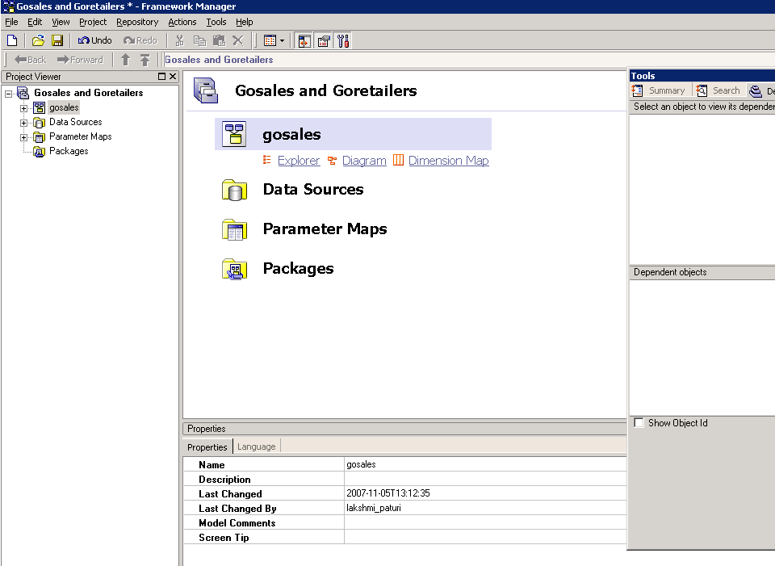

Project Viewer:

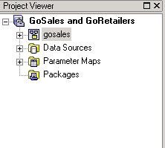

- In Project Viewer, First it is having the Project Name as “Gosales and Goretailers”
Below of this Project Name, we have the Model Name.
Note: By default, the Model Name is same as the database Name. So, here the Model Name is “gosales”.
Below of this Model Name, we should maintain 3 Layers like
Database View
Relational View
Business View/Presentation View

- To create these layers under Model Name, go to Project View Pane, Select the Go sales Namespace and right click on that → Create → Namespace. Click on the Namespace.

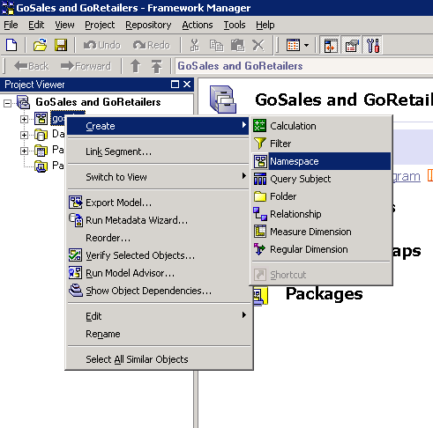

- Rename the New Namespace as “Database View” by using right clicks on that and go to Rename option or Go to the Properties Pane and enter the New Name in the Name Field.

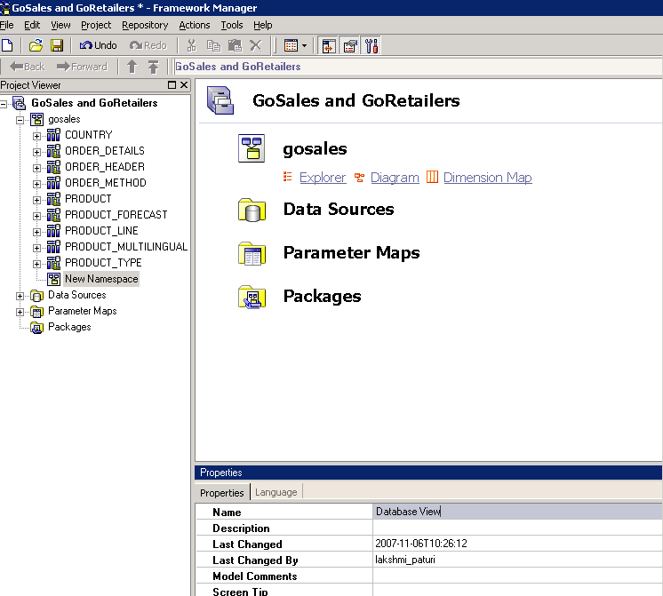

Properties Pane:

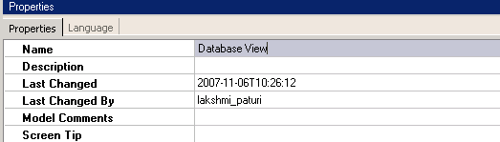

- Now, kept all the Query subjects under database View by using Cut and Paste option. First, select all the Query subjects under ‘go sales’ Name space and right click on that → click on Cut option. Now Paste all these Query subjects under database View.

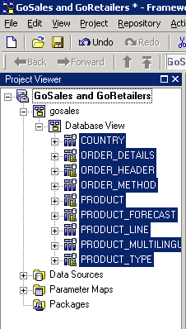

- Create another layer as “Relational View” using the same Procedure under the ‘go sales’ Name space. Now copy the Query subjects under the data base view and paste it under ‘Relational View’.

- In this Relational View, we will give the relations between the Query Subjects.
Relation Ship: Relationship is nothing but a connection that explains how the data in one Query subject relates to data in another Query subject.
While giving the relationships between these Query subjects, First of all we should know about the cardinality.

- Cardinality: The cardinality of a relationship is the number of related rows for each of the two query subjects. The rows are related by the expression of the relationship; this expression usually refers to the primary and foreign keys of the underlying table.
In brief, cardinality is having 2 digits like 1..1, 1..n, 0..1, 0...n etc. By default, cognos is having 1..1 → 1..n cardinality between the Query subjects.

Here, 1..1, 1..n means Equi joins and 0..1 and 0..n means outer joins.
Here the first digit indicates that the type of join is having between the Query subjects and the second digit indicates that the type of relationship like one-to-one and one –to-many Relationships.

Below one is the Relationship wizard, in this Wizard, we can give the relationships between the Query subjects in Relationship Expressions tab and we can able to see the sql in Relationship sql Tab

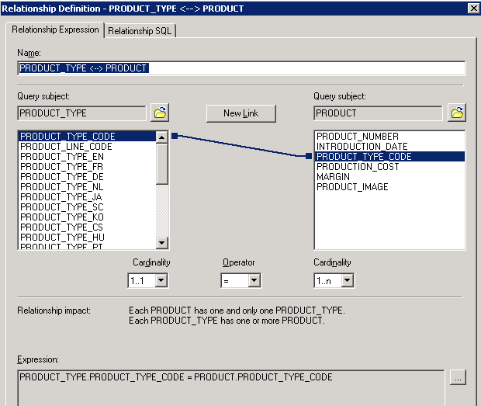

Relational View:

After giving the relationships in Relational View,

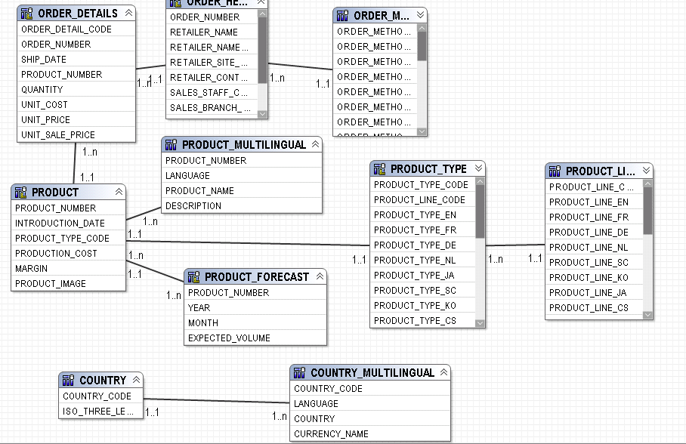

- Create one more layer as “Business View/Presentation View”. In this View, we can change the Naming Conventions of Query subjects and Query items and we can check the usage properties of Query items based on the Business Requirement. In this we may merge the Query subjects or Add/Remove the Query items based on the Business Requirements.

Lab 02 – Create the New data source and Import the Metadata.

- Objective :

Here, we want to create the new data source to import the metadata.
Steps

- Go to the Framework Manager, we have two options like “create a new Project” and “Open a Project”.
- Click on Create a New Project link.
- Enter the Project name in the ‘Project Name’ field. Project Name should be having Naming Conventions and the name should be the same of the Project Name. Ex: “Go sales and Go retailers”
- For project Location, it takes the default path is where we installed the cognos in our machines. But for better practice is create one project folder and give that folder path in this location. Click on “OK” button.
- As we know, cognos is a multilingual product and it supports multiple languages. But By default it is in English. Click on OK button.
- Now we will get the Metadata Wizard Screen. Here we have so many options to import the metadata. Depends upon the requirement, we can select any one of the above option. In this Lab book, we can go for “data Sources” option.
- Select the Data sources and click on “Next” button.
- In this wizard, click on New button to create new data source.
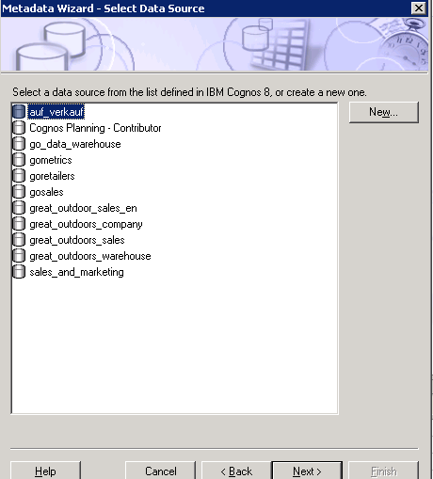

- After that click on Next button, then Enter the New Data source Name as ‘NEW_DSN’

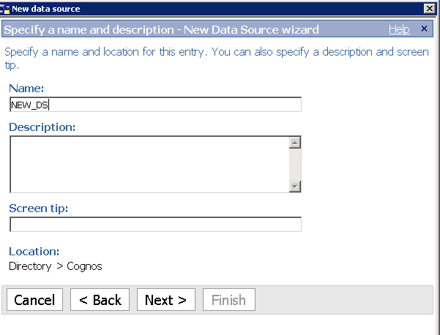
Then click on ‘Next button.

- Specify the type of the connection as “Microsoft sql server (oledb)” in Specify the connection – New Data source Wizard. Then click on Next button.
- Enter the server Name as ‘data base server Name’. Ex: if we are using the sql server, then enter the name of the server.
Under database Name field, select the radio button other than the ‘Master’ database and enter the database name.
In Signons, check the password check box and then enter user id, password and confirm password. Here user id and password are sa, sa with respectively.
Click on Test the connection link.

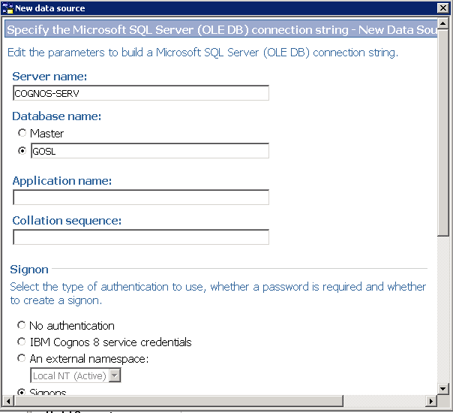

Then click on test button in ‘Test the connection – New data source wizard’. After that click on ‘close’ button.
- Click on ‘Next’ button in ‘New Data Source Wizard’ and then click on close button and finally, we will get the message as “The New Data Source wizard successfully created a data source and a first connection in the IBM Cognos 8 server” in the new data source wizard and then click on close button.

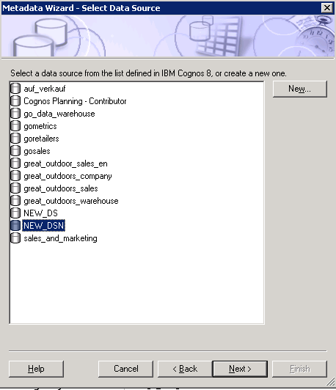

So, now we are able to see the ‘NEW_DSN’ database in the Metadata Wizard. So, select the ‘NEW_DSN’ database and the rest of the things are same as previous one to the import of metadata.

Lab 03 – Merging the two Query Subjects

- Objective :
Create a merged query subject, by combining or merging two related query subjects.

- Steps

- In a Project Viewer Pane, under ‘Business View’ Namespace, select the Product Query subject and Product Multilingual Query subject → Right click → Click on merge in New Query Subject.

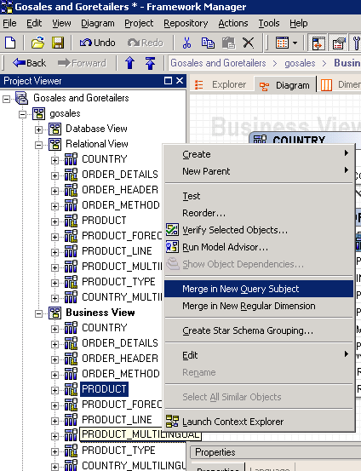

- After Merging, we will get the New Query subject as ‘Product_Product_ Multilingual’ and it is having the Query items of both ‘Product’ Query subject and ‘Product Multilingual’ Query subject.

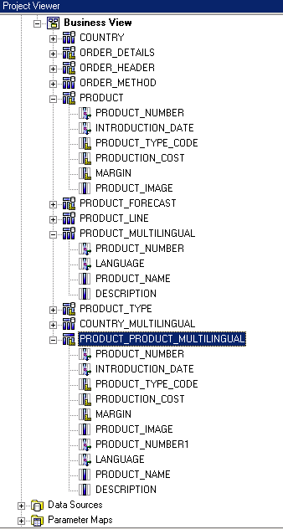

- Rename the merged Query subject as ‘PRODUCT_INFO’.
- Select the New merged Query Subject → double click on that→ From Query Definitions tab→ select the Query item which needs to be deleted.

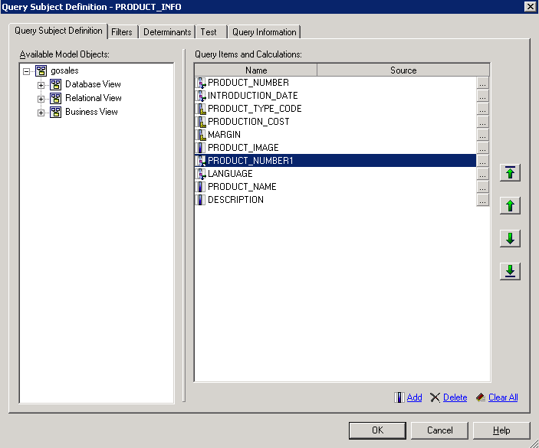

Select the Product_Number1 Query item and click on Delete link.

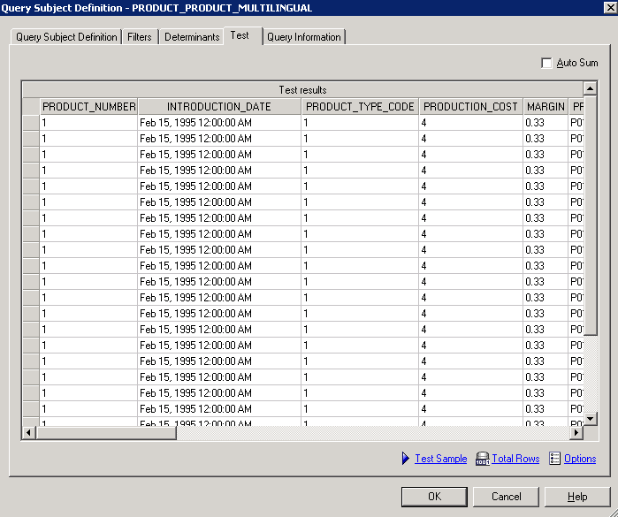

Lab 04 – Creation of New Query Subjects:

- Objective :
Create the New Query Subject.
A New Query Subject can be created from following sources.

  - MODEL (Query Subjects and Query Items)
  - Data Sources (Tables & Columns)
  - Stored Procedures.
- Steps :

- In a Project Viewer Pane, Under Project selects the Model Name Space → Right Click →Select Create → Click on ‘Query Subject’.

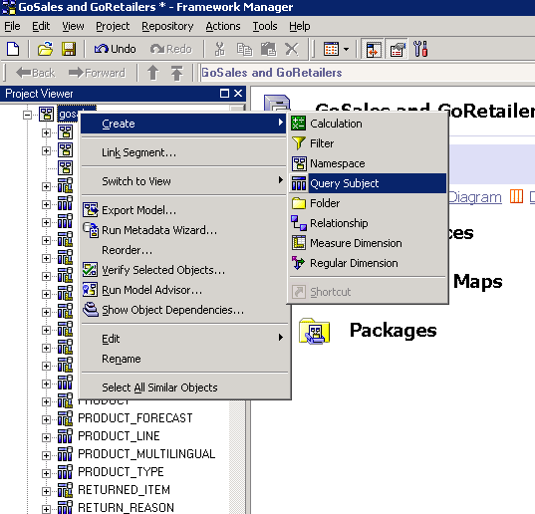

- Enter the Query Subject Name and select the Radio button as MODEL and Click on OK button.

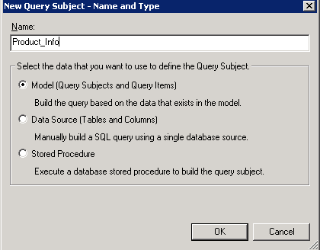

- From the Left Pane, Expand the Product Query subject, drag the following Query items and drop them on Query Items and Calculations window.

Product Number
Production Cost
Margin
Product Type Code
Product Image.

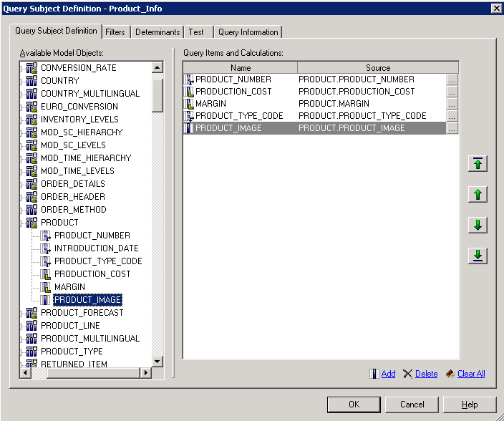

- Click on Test Tab and Click on Test Sample link.

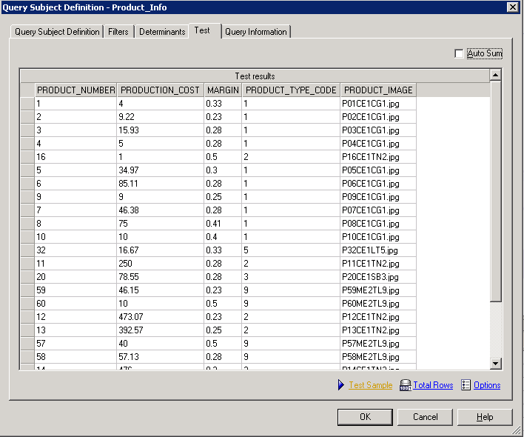

b.) Create a New Query Subject by using Data Source (Tables and Columns)

- In a Project Viewer Pane, Under Project selects the Relational_View Name Space → Right Click →Select Create → Click on ‘Query Subject’.
- Enter the Query Subject Name as ‘Proj_Info_Ds’ and select the radio button as Data source (Tables and Columns) and click on OK button.

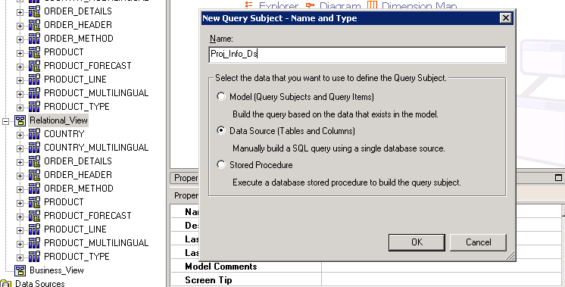

Then we are able to see the list of databases so based upon our requirement we can select particular database. After selecting that just expanding the database and we can able to select tables and columns.

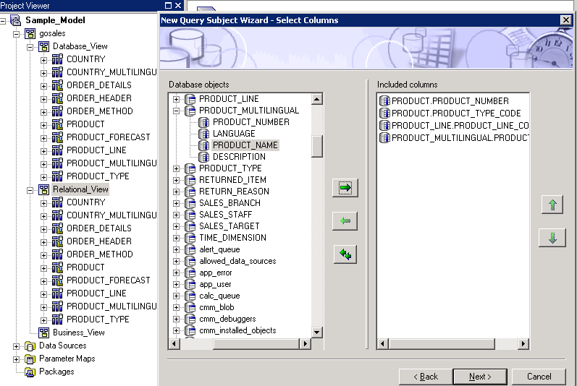

Click on Next button. Then,

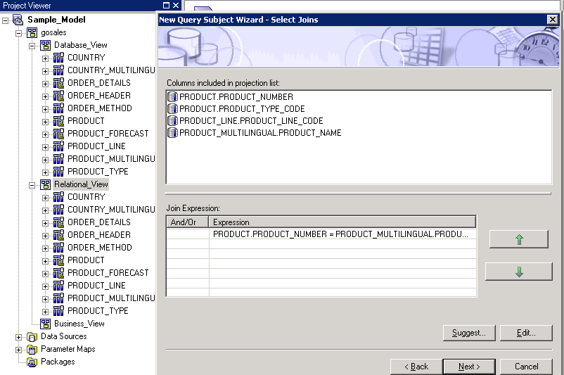

Click on ‘Next’ once again.

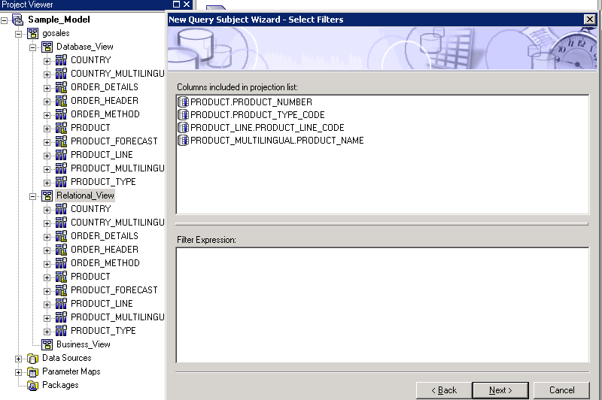

If we need to create the filter, here we can enter the filter expression. Otherwise click on ‘Next’ button. Finally we will get the SQL Window.

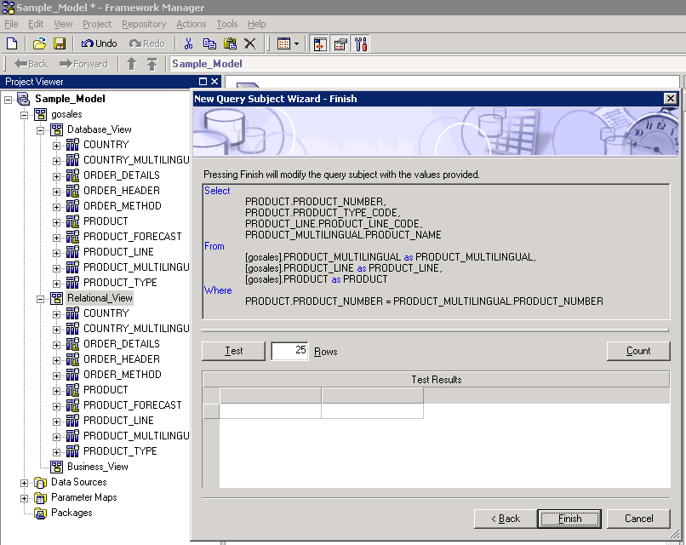

Click on the “Test” button in the above window. We will get the data and new Query subject was created with those Query items.

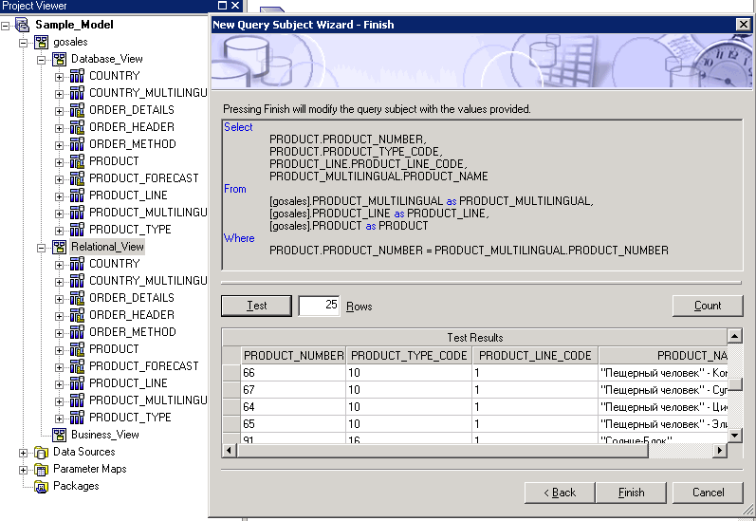

Newly created Query subject was highlighted in the below screen.

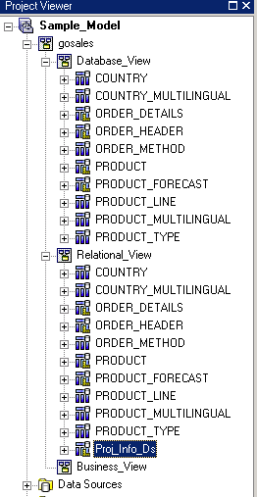

C.) Create a New Query Subject by Using Stored Procedure:

- Before doing this one, first we can create one Stored Procedure in the respective database. So we create one Stored Procedure.
- In SQL Server, select GOSL database and select Stored Procedures, click on New Sp .

Stored Procedure Used (created in SQL Server, but the following steps are the same for Oracle):

CREATE PROCEDURE PROJAVG @startdate datetime, @enddate datetime AS
Select AVG(ORDER_DETAILS.QUANTITY) AS Average_Qauntity
from ORDER_DETAILS INNER JOIN ORDER_HEADER ON ORDER_HEADER.ORDER_NUMBER = ORDER_DETAILS.ORDER_NUMBER
where ORDER_HEADER.ORDER_DATE >= @startdate AND ORDER_HEADER.ORDER_DATE <= @enddate;
GO

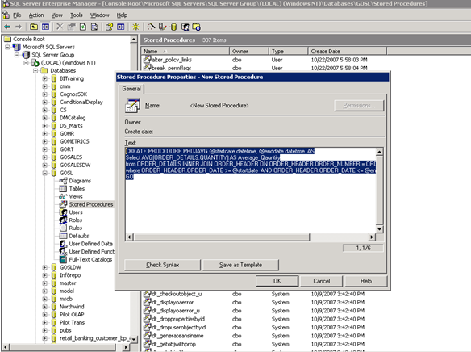

Then Stored Procedure created and it is placed in the list of Stored Procedures under that database.

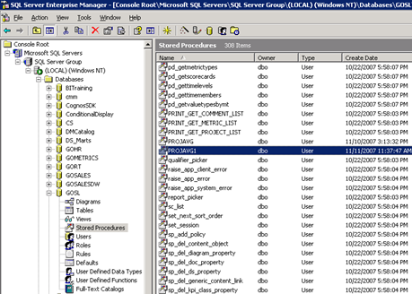

Verify this Stored procedure, we will get the data whenever we are executing.

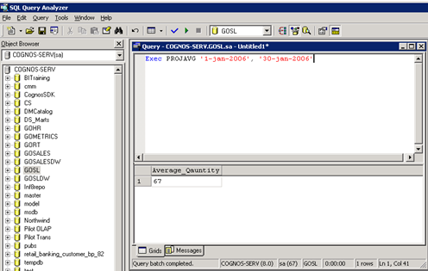

- Now, Go to FM, In a Project Viewer Pane, Under Project selects the Relational_View Name Space → Right Click →Select Create → Click on ‘Query Subject’.
- Leave the Query Subject Name as by default and select the radio button as “Stored Procedure” and click on OK button. Select the data source as ‘gosales ‘ in this exercise. Expand the ‘GOSL’ database and expand the Procedures, here we need to select the required stored procedure.

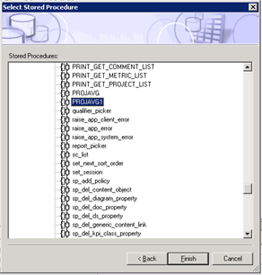

Click on Finish button. Then we will get the below Edit Screens, so that here we can pass the values for those arguments.

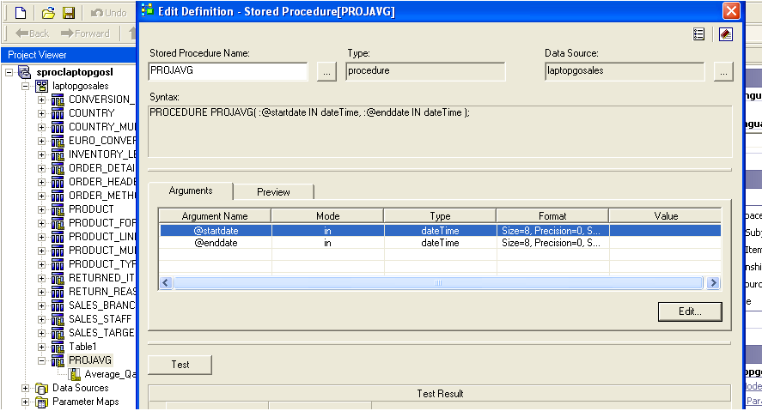

Click the edit button to hard code values for the parameters in the stored procedure.

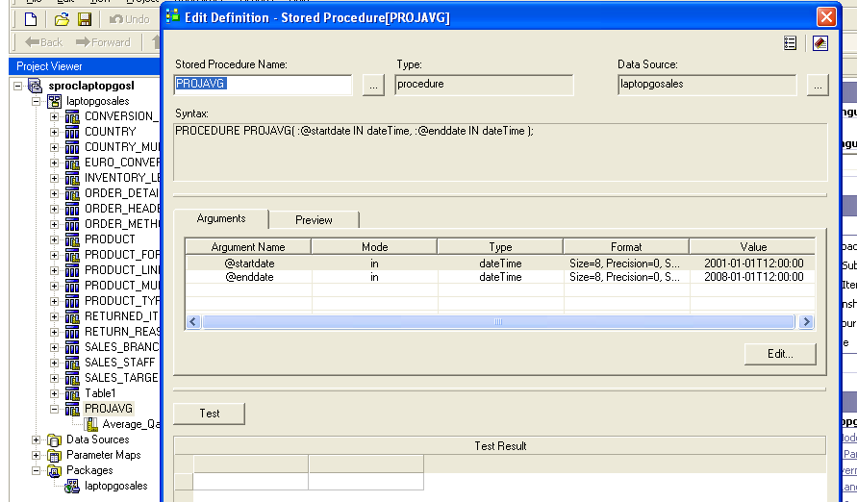

Click the “Test” button to see that it works:

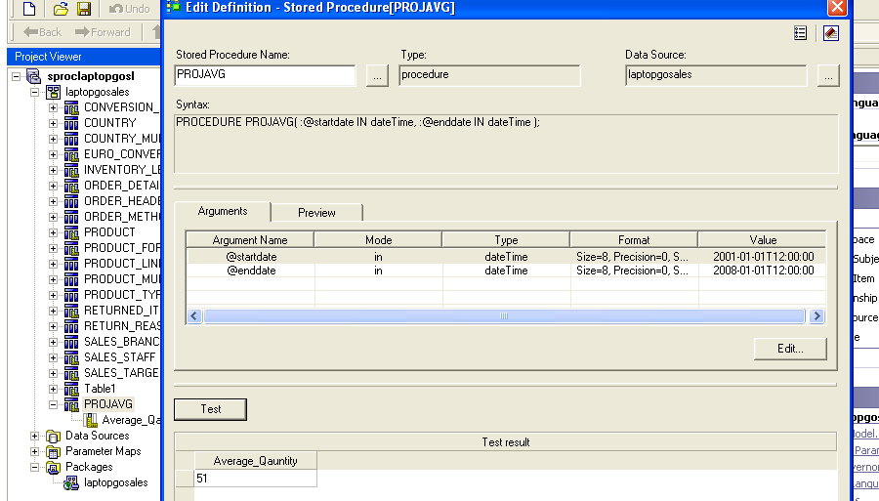

Click OK.

Lab 05 – Resolving Ambiguous Relationships.

- Objective: To resolve the loops if we are having closed paths.

- Steps

- Loop means closed path between the Query subjects. Whenever we are having closed path between the Query subjects in the model, first we should resolve those loops.
- Loops causes performance degradation of the Report and may be the chances of getting the wrong data.
- We can resolve the loops, by using shortcuts.

Loops:

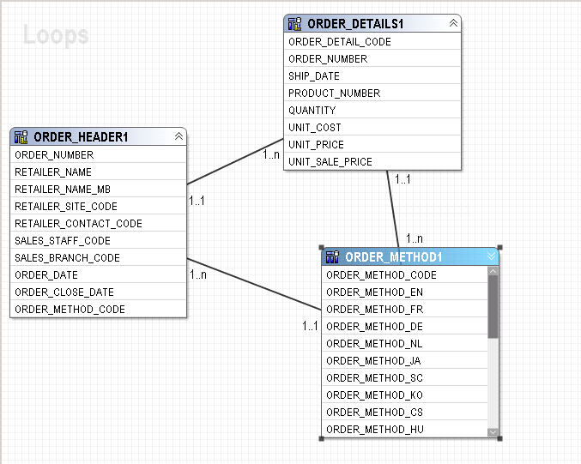

- To resolve this closed path, by using shortcuts. So, Select any one of the Query subject, right click on it and select createàshortcut.

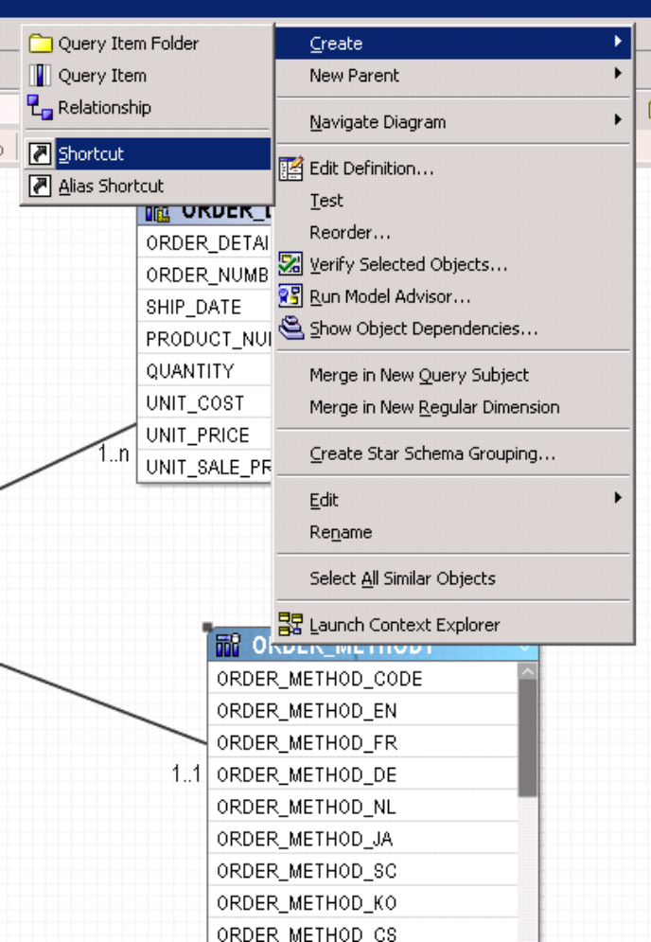

- There are sometimes if you want to represent the same information in multiple locations rather than creating the duplicate query subject, then we used to create shortcuts.
- Just delete the relations between Order details and order method and give the same relation between order details and shortcut to order method. We can rename that ‘shortcut to order method’ as order method 1(alias).

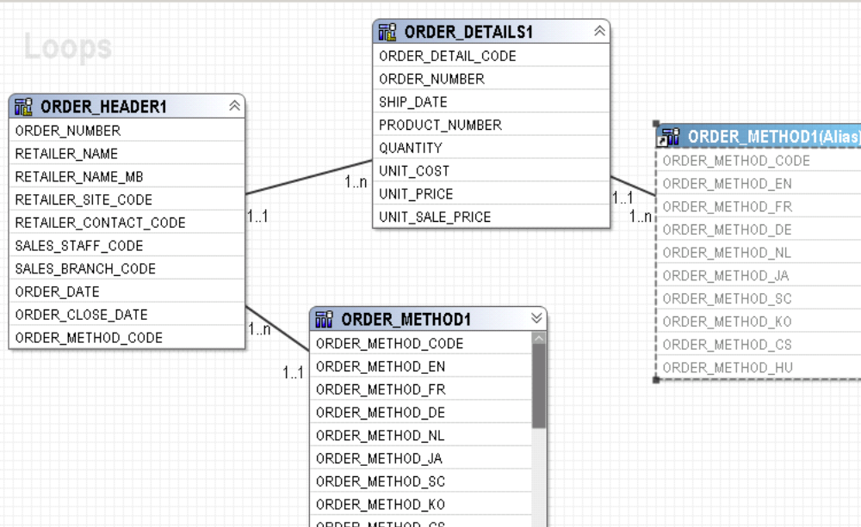

Lab 06 – Multi Database Access

- Objective :

A Project can be created from multiple databases. These databases can be either Homogeneous or heterogeneous.
- Steps

- Initially we are importing metadata from one database. Here Datasource name as “Gosales”.
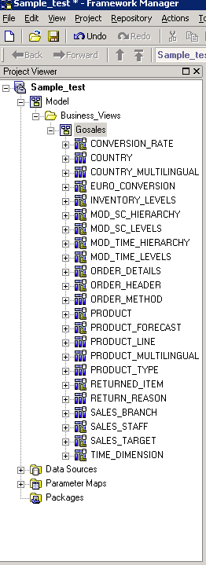
- In a Project Viewer pane, select the folder Business Views → right click→ click on select create, click on Name space.
- Rename the namespace as “Go_Retailers”. Select the Go_Retailers namespace→ right click→ click on Run Metadata Wizard.

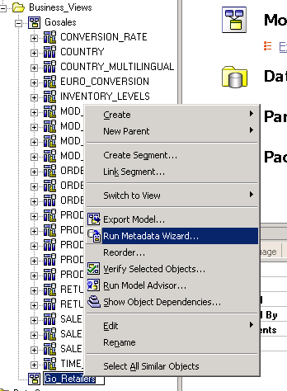

- Select the Metadata source as ‘Data Sources’ and click on Next button. Select the database as “Go retailers” database and click on ‘Next’ button.

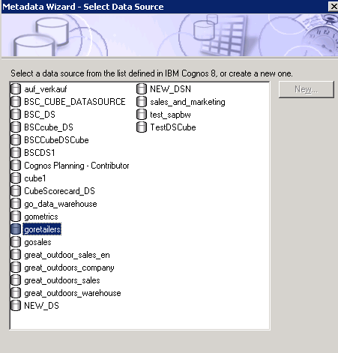

- Select the check box as ‘Tables’ and click on Next→ leave the defaults in the relation wizard-→ Click on Import→Click on Finish.

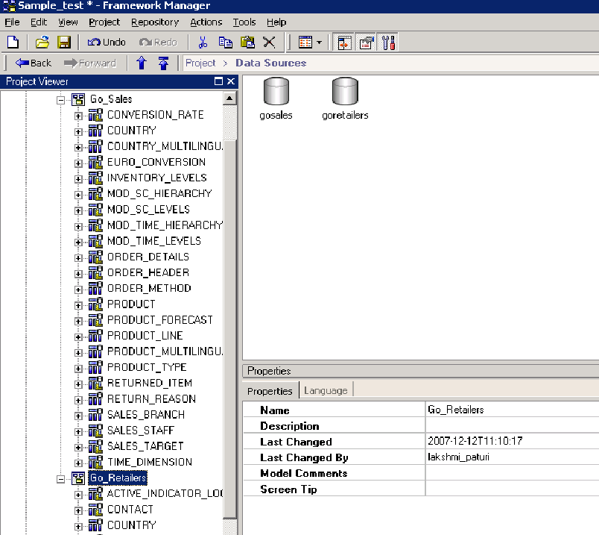

- From Go_Sales Namespace, Expand ‘Order_Header’ Query subject, select Retailer_Name’ Query item, hold the Query item using the ‘ctrl’ key in the key board. From ‘Go-Retailers’ Namespace, expand ‘Retailer’ Query subject, select the ‘Company_Name’ Query item→ right click→ click on create relationship.

- Click ok.

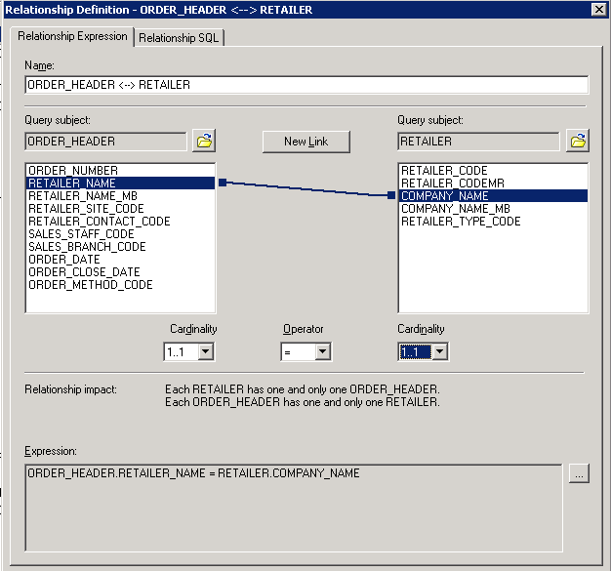

Lab 07 – Creation of Parameter Maps:

- Objective :
Creation Of Parameter Map.

- Steps

- A Parameter map is a key_Value Pair used in creating the conditional Query Subjects. Click the chart object.
- In a Project Viewer pane under project select the parameter maps→ right click→ select create→ Click on ‘Parameter Map’.
- Enter the parameter name as ‘locale Map’

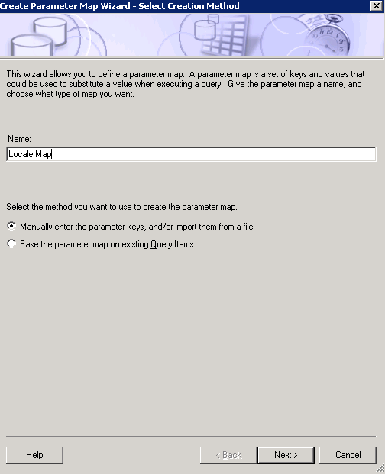

Leave the defaults and click on Next.

- Enter the default value as ‘en’ and give the rest of the values in key and Values.

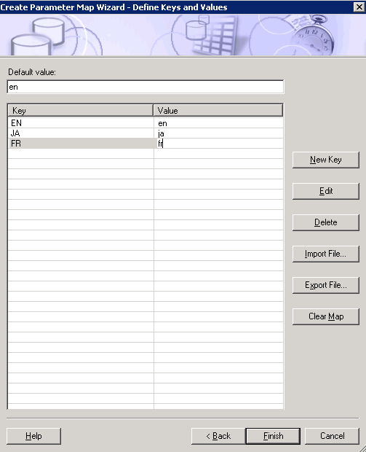

- Click on ‘Finish’ button. Now we are able to see the created parameter map Under parameter maps in the Project Viewer pane.

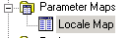

Lab 08 – Create a macro to change the multilingual column names dynamically.

- Objective :

Create a macro to change the multilingual column names dynamically.

Macros are fragments of code that you can insert in any part of the sql statement which can execute at Query run time. We can include Parameter Maps and session Parameters.

Macro Syntax: #$Name of Parameter Map{run locale}#

- Steps

- First, we will create one parameter map same as above one.
- In a Project View Pane→ select the ‘Product_line’ Query subject→ right click→ Click on Edit definition→ change the default sql Query as shown in the below.

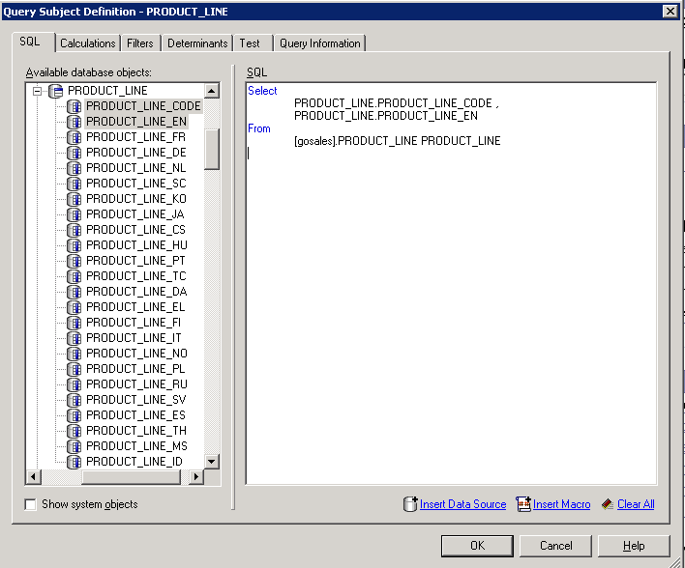

SQL:

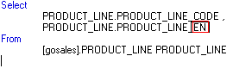
- Remove the ‘EN’ from the sql and insert macro at that place.
- To insert Macro, there is one button ‘To insert macro’ or enter the ‘#’ key from the keyboard.

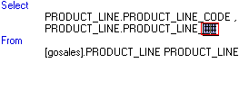
- Click on Hand icon between the two ‘#’ icons, then Macro editor window is displaying. Expand the parameter maps from the left pan→ just drag and drop into the Macro definition.
- Similarly, expand the session parameters and drag “Runlocale” and drop into the macro definition.

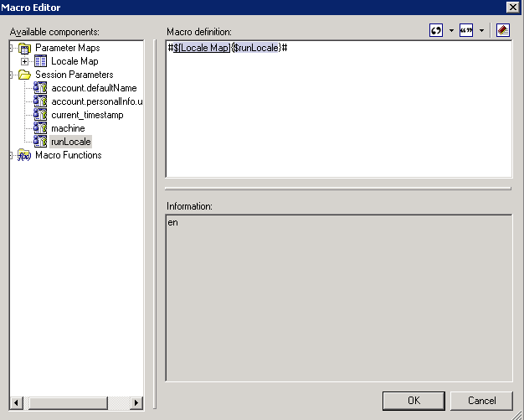

- Click on ok. If we want to test the data, go to test tab and click on test sample.

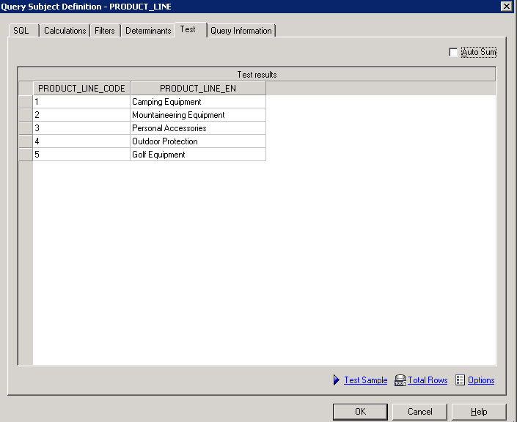

- Here, we can override the default values using session parameters.
Go to Project Menu→click on session parameters.

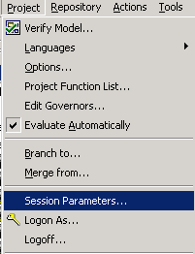
- We can take another value to override the existing value. But, make sure that we have those set of values in our parameter map. Here I am using to override the value with ‘ja’ as shown in the below screen shot.

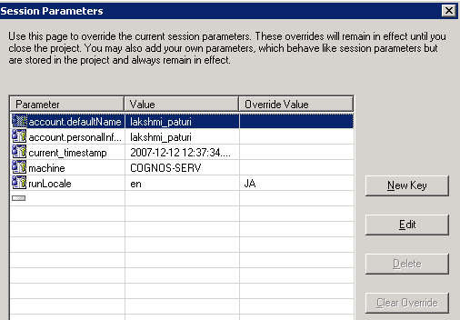

- Check once the data, Go to test tab and click on ‘Test Sample’. Then we will get the data in Japanese language.

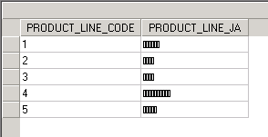

Lab 09 – Creation of Query items and Filters and Model Filters and Model Calculations.

- Objective :
In this, we can create Query items and filters particularly in one Query subject and will create the Model Filters and Calculations.

- Steps

- Query items are the smallest piece in the model. We used these Query items in the report development. Sometimes we can create new Query items based on the existing Query items.
- In a project View pane, select the Query subject as ‘Product’. Double click on Query subject and Go to ‘calculation’ tab click on ‘Add’ button.

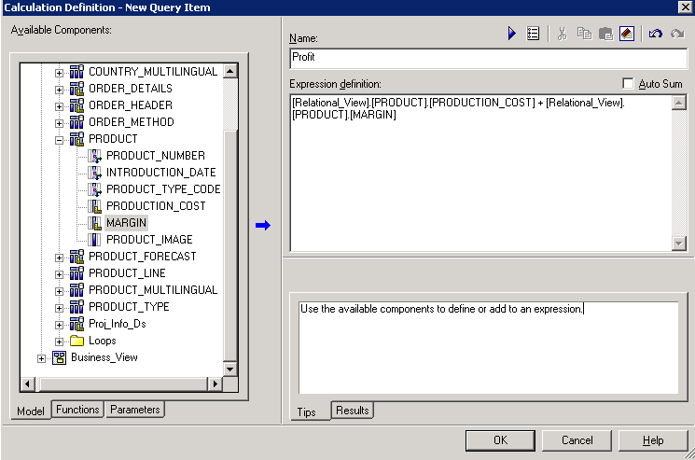
- Click the Run then we will get the data based on the Expression.

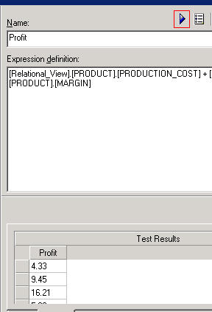

- But, this calculated item is belongs to only particular this Query subject.

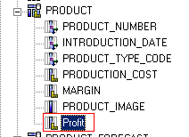

- Similarly we can create filters in Filters tab. Click on Add button, Filter definition window opens and we have to give our condition in the expression wizard.

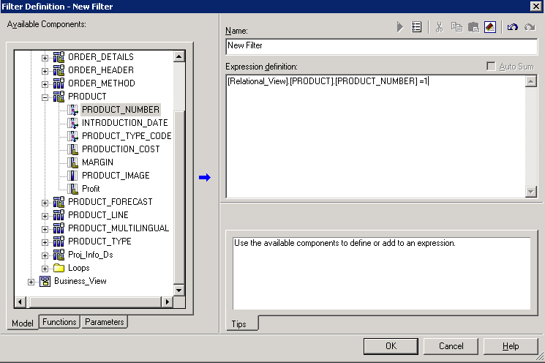

- If we want to test the filter, Go to ‘test’ tab and click on test sample.

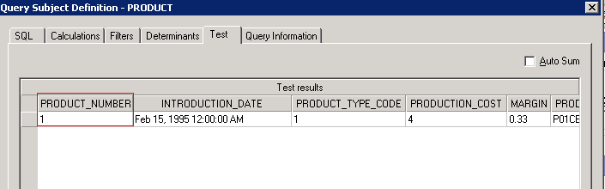

- Here this filter will work only on this “Product” Query subject.
- Filter is having Usage Properties. So, based upon our requirement we can change these Usage Properties.

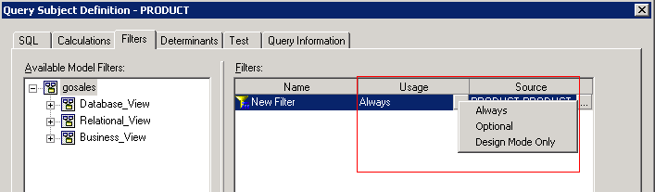

Model Filters and Calculations:

- In a Project viewer pane, under project select the ‘Business_View’ Namespace→ right click→ select create→ click on Filter

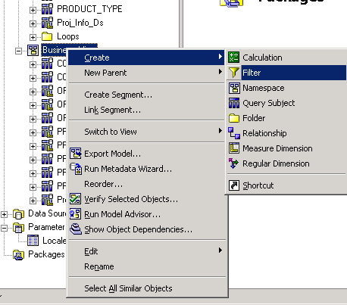
- Enter the Filter Name, from the left pan, expand the Query subject, double click on Query item→ type the operator as ‘=’and the value is 1.

So, finally condition is ‘Country code=1’

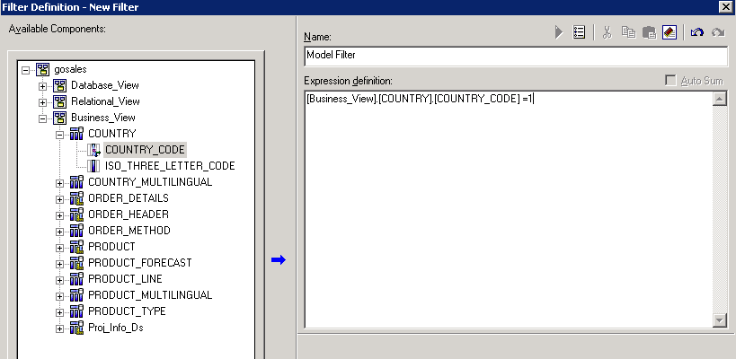

- Click on ‘ok’ then we have to see this filter under ‘Business View’. The main purpose of Model Filters is Reusability. We can reuse these filters in ‘n’ no. of Reports under this package.

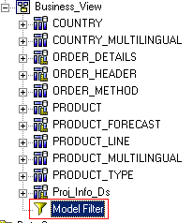

Model Calculations:

- In a Project viewer pane, under project select the ‘Business_View’ Namespace→ right click→ select create→ click on Calculate
- Enter the Calculation Name as ‘Model Calc’ and drag and drop the Query items into the Expression Editor and click run to see the output.

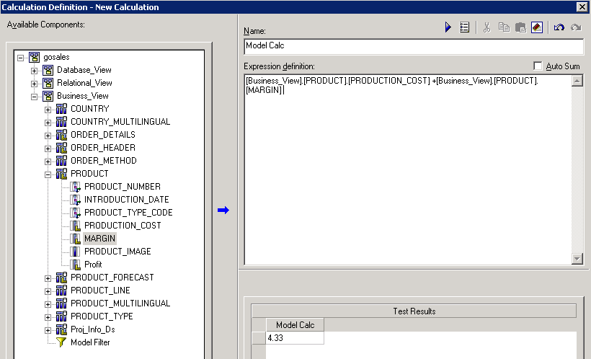

- Finally, we will see the created calculation under Businees_View.
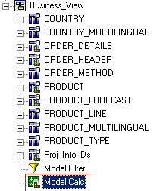

Lab 10 – Creation of Package and Publish Package.

- Objective :
Create Package and publish the package.

- Steps
A package is a subset of a project. It must contain all the information that a specific user or group of users needs to create reports.

- In a Project Viewer pane→ under Project→ select the packages→ right click→select create→ click on Packages

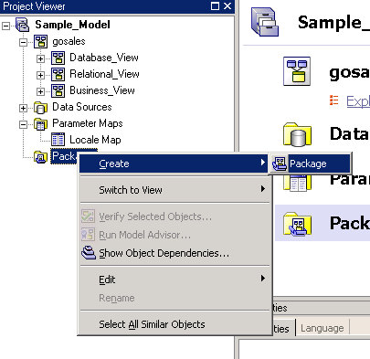

- Enter the Package Name and click on Next button. Package Name should be anything but better practice is same as the Project Name along with date/versions.
- Here we can unselect for Database_View, hidden for Relational_View, only select for Business_View’ means we keep all the required information in Business_View based on the Report Requirements.

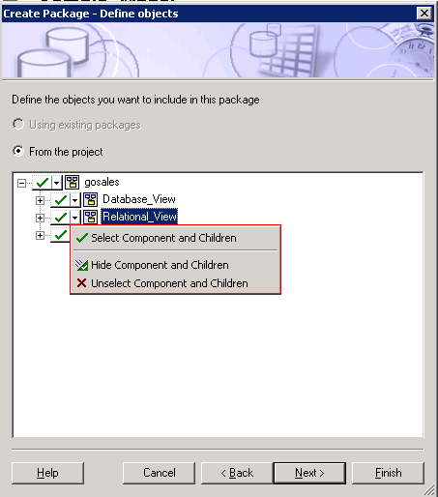

So,

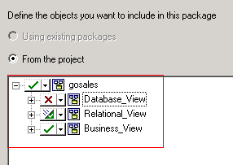

- Click on ‘Next’ button. Here we can select the function set from the available function set.

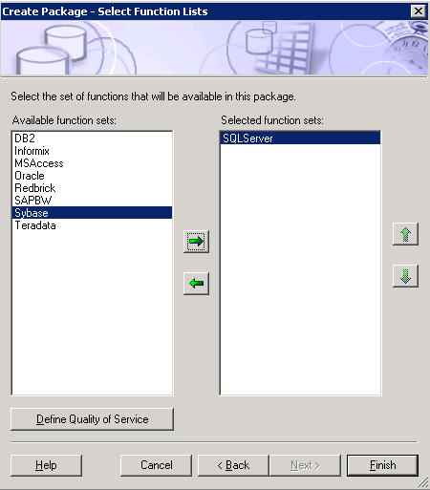

- Click on Finish button.

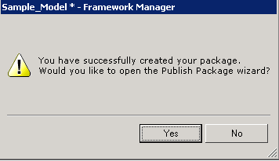

- Click on ‘Yes’ button. Then we will see the ‘Publish wizard’ screen.

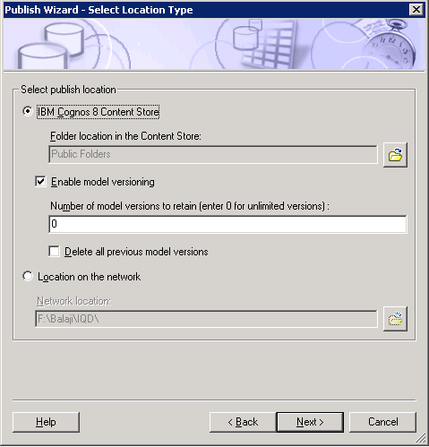

- Click on “Next” button → Then ‘Publish wizard—Add Security’ screen is displaying. If we want to give security for the package, here we can give it. Otherwise click on ‘Next’→Then Click on “Publish” button.
- Click on Finish button. And Click on ‘Save’ in menu icons to save the package. We can able to see that package under packages in the Project View Pane.

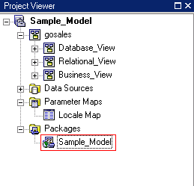

Lab 11 – Update and Synchronize

- Objective :

You create one Package and develop some reports based on that Package. But, In Middle of the Project they are some modifications in the database. So for those scenario’s we should use these update and Synchronize. So, mainly used whenever we will get change requests in the database.

- Steps to Create the Target Report

- In the Project View Pane, select particular Query subject→ Go to ‘Tools’ Menu→select ‘Update object’.
- Automatically, what are the changes are occurred in the database, those will effect in the Framework Manager when we use ‘update object’. Without using this Property, modifications in the database are not effected in the FM.

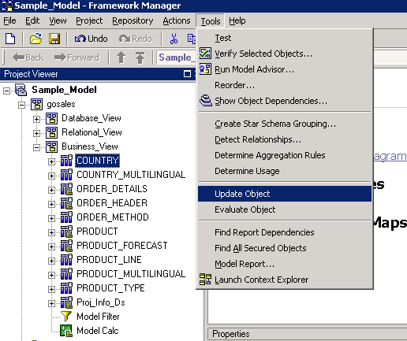

Synchronize:
It can give the backup of the model before updating in FM and along with Backup it performs the same functionality of Updating.
- Select the Query subject in FM→ Go to ‘Project’ Menu→ Select Synchronize and click it.

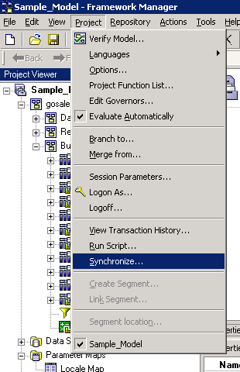

- We will get Synchronize screen. It takes back up by default in the project folder, if we want to give another location, we can browse it.
- Click on Run icon which is highlighted in the below screen. After that click on ‘Accept’ button.
Then it will give the backup of before updating and it performs the update Functionality.

